The Shrubberies School
Headteacher Pack May 2025
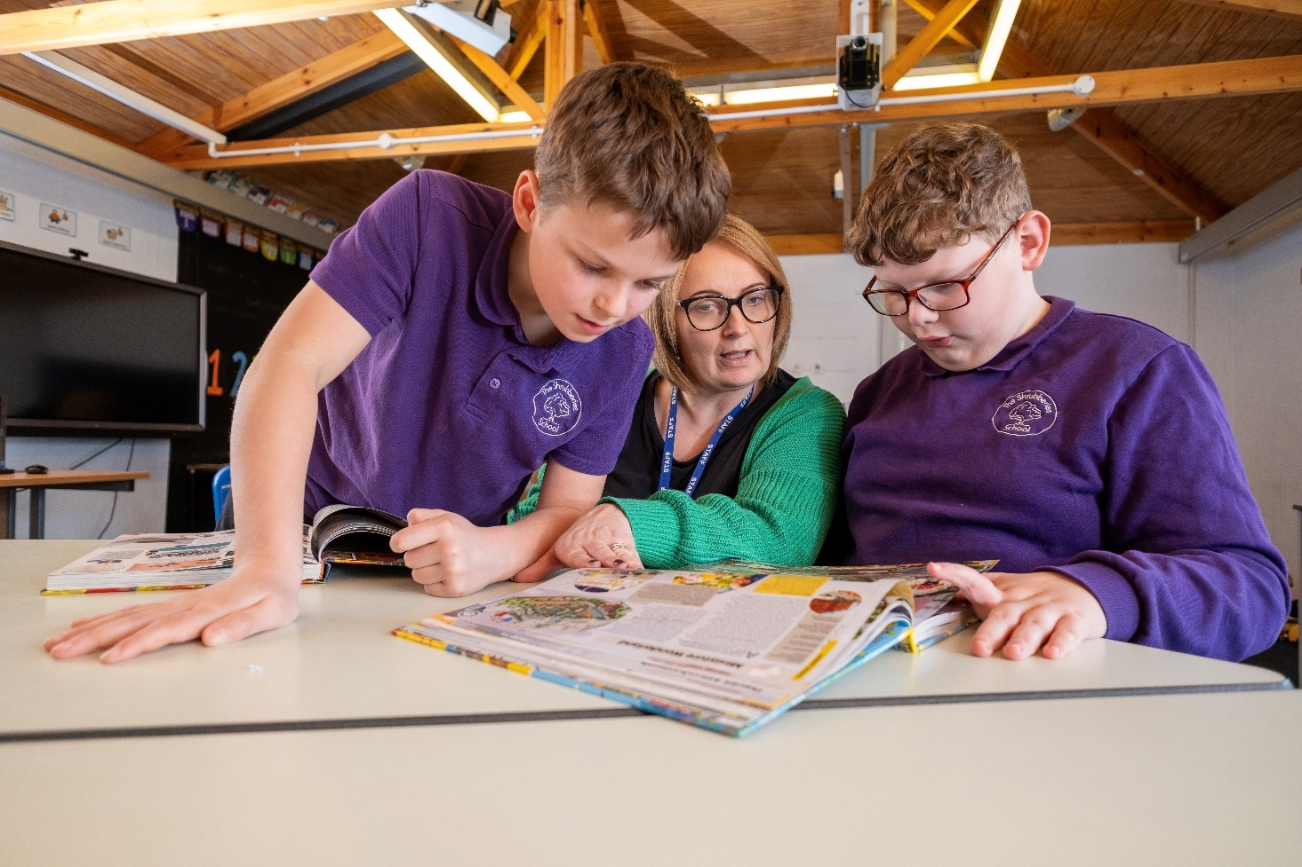

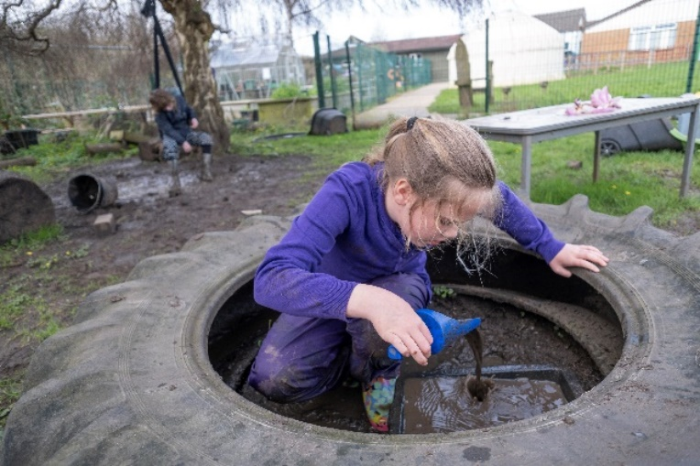

Contents
Page
1 Front Cover
2 Contents Page
3 Letter from the Chair of Governors
4 About the Shrubberies School
5 Aims and Values
7 Job description
11 Personal specification
14 Job advert

Letter from the Chair of Governors

Dear Applicant

Thank you for your interest in applying for the role of headteacher. The governors of The Shrubberies School are looking for a headteacher that can continue with carrying the school forward in our children’s journey through education. We have a strong leadership team that are dedicated and passionate about our curriculum, extracurricular activities and personal development programmes, which allow our students to grow into the excellent rounded young people that are proud to be part of our wider community. This is evident as we have many ex-students regularly visit our May Fayre, Panto performances and concerts. The governors are proud of the fact that The Shrubberies prides itself on putting each and every one of its children first and it goes without saying that the children are at the heart of everything we do. The safety, wellbeing, and happiness of our children comes first and we are very proud of their academic qualifications. You will see from our two recent Ofsted reports that the school is solidly ‘good’ in all areas, but we do not rest on that at all. We are a progressive school, that is always looking for improvement and we will never sit still.

I would urge anyone thinking of applying to be our new headteacher to visit us so that you can see our amazing school first hand and experience just what makes The Shrubberies School so special for the community, our staff and above all our children. We look forward to meeting with you so that you can share with us our vision for the future.

Closing date for applications is: Friday 27th June 2025 at Noon.

Applications should be returned by email to: Wendy Gallagher, Governor Services, Gloucestershire County Council - email: governor.services@gloucestershire.gov.uk

Yours sincerely

Sue Medcroft
Chair of Governors
The Shrubberies School
About the Shrubberies School
Our absence for the year to date is 8.43% compared to the national special schools of 12.7%.
There are four departments. Lower, Middle and Upper School are led by Assistant Headteachers. The Apperley is led by the Senior Assistant Headteacher.

The Shrubberies is a progressive school that strives for the best for the children. It has a long history and reputation of being a ‘Good’ School. It has been since its first Ofsted inspection in 2000! The latest inspection in April 2024 stating “Respectful relationships between staff and pupils help pupils to feel safe and happy in school.”
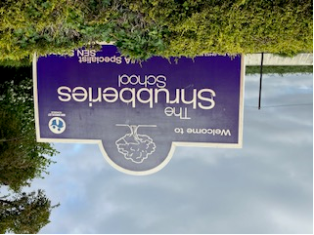
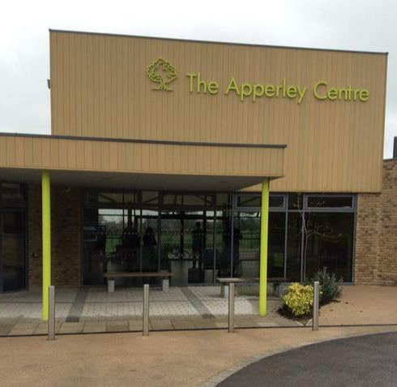
The Shrubberies School and The Apperley Centre provide specialist education for 136 pupils aged 2 to 19, who have severe or profound learning difficulties. We offer personalised, outward looking programmes to enable pupils to achieve their best, no matter what barriers they face.

The Shrubberies School is a split site. The main school is for pupils from Key Stage One to Key Stage Four. The Apperley Centre is out post 16 FE College.
The school is a calm place, where pupils’ social, emotional and mental health development is a priority.

Aims and Value
The School Aims:
- To develop the full potential of each pupil in a respectful, inspiring and supportive environment.
- To provide a broad, balanced, differentiated and relevant curriculum that motivates, inspires and takes into account pupils talents and interests.
- To develop self-regulation, self-esteem and self-confidence by providing activities and programmes which allow pupils the experience of success.
- To prepare our pupils for the next stage of their education or life, through developing their independence and sense of responsibility.
- To establish effective communications between home, school and external agencies, creating a partnership to best meet the needs of our pupils.
- To offer pupils a broad range of stimulating and enrichening experiences, both within school and in the community.


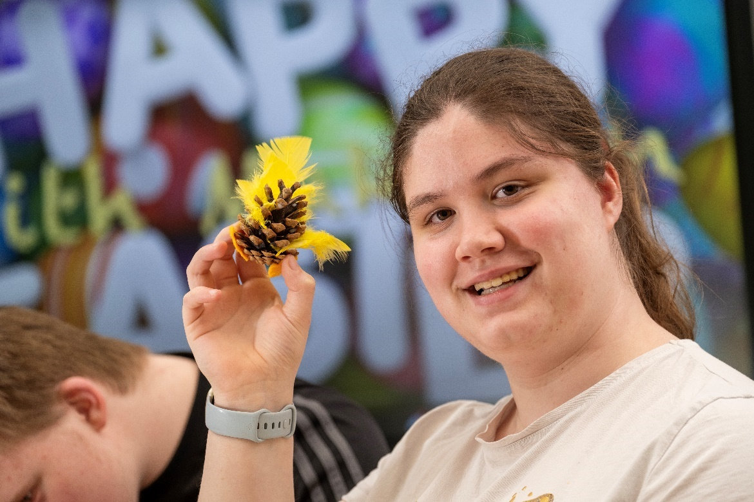

Values
- At the Shrubberies School pupils are valued and respected equally.
- They are recognised as individuals with differing personalities and the ability to excel in differing ways.
- Each pupil is respected regardless of gender, race, creed, gender identity or disability and it is believed that with a positive and optimistic approach from all concerned, each and every pupil can be helped to reach his or her potential in preparation for their life as active citizens.
- Pupils are supported in a calm and non-confrontational manner, to behave in a way that enables them to make the most of their opportunities. They are encouraged to develop respect and understanding of the needs and rights of others, as well as their own.
- We recognise that the school staff are not working in isolation and the view and experiences of both pupils, parents and other professionals are taken into consideration at all times.
Job Description
Job Description
Position: Headteacher
Accountable to: The Governing Body
Salary Range - Group 5 - £81,441 - £94,332 (L21 -L27)
NOR 136
Nature of Contract: Permanent, Full Time
Pension: Teachers Pension Scheme

Purpose
The Headteacher will provide vision, ambition, leadership and strategic direction, underpinned by clear values, to ensure that the school is managed and organised effectively by working strategically with all partners and stakeholders to develop outstanding provision to transform the educational and future opportunities for all pupils.

Statutory and Non-Statutory Requirements
- Fulfil all the requirements and duties as set out in the School Teachers’ Pay and Conditions Document relating to the conditions of employment of the Headteacher.
- Operate within the framework outlined in the Headteacher’s Standards to ensure best practice within our setting
- Seek to achieve any performance criteria, objectives or targets agreed with, or set by, the Governing Body in accordance with the requirements set out in the School Teachers’ Pay and Conditions document.
- Promote and safeguard the welfare of all children, young people and staff within the school by ensuring that the school’s policies and procedures relating to safeguarding children and vulnerable young adults are fully implemented and followed by all staff sensitively and effectively.

Main Duties
- Be the lead professional and positive role model within the school community.
- Work to an agreed vision, underpinned by clear values which are evident throughout the school.
- Have a direct impact in raising achievement to the highest level through uncompromising high ambition.
- Lead by example in determining the professional conduct and practice of teachers to the highest standards.
- Enable a climate that supports pupils to display exemplary behaviour.
- Be a positive role model in helping others recognise and celebrate difference and respect cultural diversity.
- Have ambition and seize opportunities for the school beyond its boundaries.

Personal Qualities
- Hold and articulate clear values and moral purpose focused on providing an outstanding education for all pupils.
- Demonstrate optimistic personal behaviour, positive relationships and attitudes towards pupils, staff, parents and carers, Governors and the local community.
- Lead by example, with integrity, creativity, resilience and clarity, drawing on your own scholarship, expertise and skills, and that of those around you.
- Sustain wide current knowledge and understanding of Education, SEND and school systems locally, nationally and globally and pursue continuous professional development.
- Work with political and financial astuteness, within a clear set of principles centred on the school’s vision, ably translating Local Authority and National Policy into the Special School context.
- Communicate compellingly the school’s vision and drive strategic leadership, empowering all staff and pupils to excel.

Pupils and Staff
- Demand ambitious standards for all pupils with particular reference to personalised progression, overcoming barriers to learning and disadvantage whilst advancing equality and instilling a strong sense of accountability in staff for the impact of their work on pupils’ outcomes.
- Secure excellent teaching through an analytical understanding of how pupils learn and the core features of successful classroom practice and curriculum design, leading to rich curriculum opportunities and enhanced pupils’ well-being.
- Establish an open educational culture as a basis for sharing good practice within and beyond school, drawing on and conducting relevant research and robust data analysis.
- Create an ethos within which all staff are motivated and supported to develop their own skills and subject knowledge and to support each other.
- Identify emerging talents, coaching current and aspiring leaders in a climate where excellence is the standard, leading to clear succession planning.
- Hold all staff to account for their professional conduct and practice.

Organisational Management
- Ensure that the school’s systems, organisation and processes are well considered, efficient and fit for purpose upholding the principles of transparency, integrity and probity.
- Provide a safe, calm and well-ordered environment for all pupils and staff focused on safeguarding pupils and developing their exemplary behaviour in school and the wider society.
- Establish rigorous, fair and transparent systems and measures for managing the performance of all staff, addressing any underperformance, supporting staff to improve and valuing excellent practice.
- Welcome strong governance and actively support the governing body to understand its role and deliver its functions effectively, in particular in setting school strategy and to hold the Headteacher to account for pupil, staff and financial performance.
- Exercise strategic curriculum led financial planning to ensure the equitable deployment of budget, resources and accommodation in the best interests of pupils’ achievements and to maintain a sustainable future.
- Distribute leadership throughout the organisation, forging teams of colleagues who have distinct roles and responsibilities and hold each other to account for their decision making.

Continuous School Improvement
- Create an outward facing school which works with other schools and organisations in a climate of mutual support and challenge to champion best practice and excellent academic outcomes.
- Develop effective relationships with fellow professionals and colleagues in other public services to improve social and health outcomes for all pupils.
- Challenge educational orthodoxies in the best interests of achieving excellence, harnessing the findings of well evidenced research to drive school improvement.
- Shape the current and future quality of the teaching profession through high quality training and sustained professional development for all staff.
- Model entrepreneurial and innovative approaches to service improvement, leadership and governance, and to be confident of the vital contribution of internal and external accountability.
- Inspire and influence others within and beyond school to believe in the fundamental importance of Special Education and to promote its value.

The Headteacher will contribute to the school’s objectives in service delivery by:
- Enactment of Health and Safety requirements and initiatives as directed
- Compliance with Data Protection legislation
- At all times operating within the school’s equal opportunities framework

A copy of this document will be held on file in school and may be amended at any time after consultation with the post holder

Person Specification for Headteacher

Essential | Desirable
Qualification and CPD
- A record of continuous professional development that includes training in leadership and management. | - NPQH, or commitment to completing within 2 years  - Advanced qualification such as M.Ed  - Recognised SEND qualification
Experience
- Serving Headteacher/Deputy Headteacher/Senior Leader role with experience of catering for pupils with PMLD, MALD, SLD, AS Experience of developing and implementing programmes for staff development. | - Working experience across all Key Stages  - Experience of Post 16 Provision  - Experience of managing a significant project
Key Skills and Competencies
- To foster a culture of open and transparent communication with all stakeholders  - Highly developed leadership skills with the ability to motivate, delegate and empower  - Able to analyse data, evaluate and assess school’s performance and develop improvement plans  - Able to set the direction for school and create a clear vision  - Able to engage positively and support pupils by recognising their progress in all areas and celebrating them with them. | - Competent to deliver health and safety leadership responsibilities  - Able to enhance school income
- Able to develop highly positive relationships with parents and carers and recognise their value as partners in achieving the best outcomes for pupils.
- Able to develop staff confidence, capacity and impact by establishing supportive relationships that encourage a positive response to challenge and guidance.
- Able to champion the school and work with community organisations
- Able to work constructively with Governors, the LA, Social Services, other schools and partners
- Excellent knowledge of the current issues, statutory requirements and trends impacting on special education
- Able to organise, prioritise and manage work effectively
- Knowledge of the arrangements affecting academy schools
- Able to develop an effective and trusted working relationship with the School Business Manager to ensure good school administration and budget management
- Able to plan for improvement and drive initiatives forwards
- Able to inspire staff to create and maintain a stimulating learning environment
- Excellent communication skills
- Ability to hold self and others to account
- Excellent understanding of curriculum design to meet the needs of all pupils
- Well-developed evaluative skills that ensure an accurate view of the school’s strengths and weaknesses
- Outward-looking and keen to embrace the local community
- Welcome appropriate challenge, be reflective and open to change
- Excellent knowledge of safeguarding. Experience of raising standards of achievement
- Experience of leading, managing and developing a team
- Experience of safeguarding and promoting welfare of children
Personal Qualities
- Deep commitment to inclusion, valuing diversity and championing excellence for all
- Enthusiasm, commitment and vision to support the existing child centred ethos of the school
- Sense of humour and the ability to diffuse challenging situations tactfully.
- Commitment to, and a genuine interest in, the pastoral welfare of the school community
- Operate with integrity, fairness and honesty and committed to maintaining confidentiality, as appropriate
- Able to work under pressure, organise workload and maintain personal resilience and wellbeing

Mandatory Requirements
- Committed to equal opportunities, principles and practice
- To uphold the seven Principles of Public Life
- To ensure that all statutory duties are carried out fully at all times.



The Shrubberies School

Headteacher
Salary Range - Group 5 - £81,441 - £94,332 (L21 -L27)
NOR 136
Required for January 2026

A vacancy has arisen for a Headteacher from January 2026 to lead our amazing school.

The role will require you to take full responsibility for leading a skilled and hardworking leadership and staff team to meet the special educational needs of pupils aged 2-19 years with SLD and PMLD.

This is a key role in our journey to continually strive for improvement in a happy, learning environment for all. Candidates should have high professional standards and a commitment to developing the teaching and learning of special needs within a supportive provision. They should be passionate about keeping the children at the heart of the school.

The school is an active member of Stonehouse community. We have a separate Post 16 provision, The Apperley Centre, a short distance from the main school. We have excellent learning facilities both inside and outside on both sites. We take pride in using a variety of learning environments to provide a wealth of engaging activities and experiences for our children and young people. We value partnership working and value all members of the Shrubberies Community. Staff, parents and children have a voice and are listened to.

Visits to the school are encouraged, please contact Wendy Newby to make an appointment. Please telephone 01453 822155 or email: head@shrubberies.gloucs.sch.uk.

If this is a position that you would be interested in, please download a copy of the application pack and application form from our website or contact Wendy Gallagher, Governor Services, Gloucestershire County Council. E-mail: governor.services@gloucestershire.gov.uk or telephone 01452 427802.

The closing date for applications is: Friday 27th June 2025 at Noon.

Interviews will take place on Wednesday 16th and Thursday 17th July 2025.

The Shrubberies School is committed to safeguarding and promoting the welfare of children and young people and expects all staff and volunteers to share this commitment. All posts will be subject to an Enhanced DBS check.

